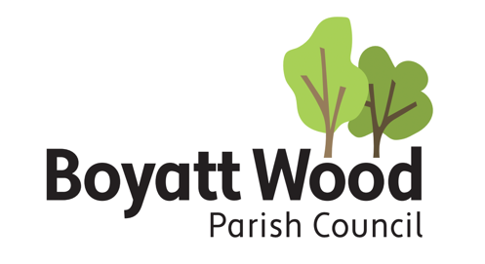
clerk@boyattwood-pc.gov.uk

9 August 2022

Notice is hereby given that the MEETING OF BOYATT WOOD PARISH COUNCIL will be held at 7.00 pm on Tuesday 16 August 2022, in The Meeting Room, St Peters Church, Boyatt Wood to which you are hereby summoned for the transaction of the business specified below.

T J Predeth

T J Predeth
Clerk to the Council

Admission of the Public and Media
Members of the Public and Media are welcome to attend in accordance with the Public Bodies (Admission to Meeting) Act 1960 Section 1 and to report on the meeting in accordance with the Openness of Local Government Bodies Regulations 2014.

AGENDA

- APOLOGIES FOR ABSENCE
To receive and approve apologies for absence.

- REGISTER OF INTERESTS AND DISPENSATIONS
To receive any Declarations of Interest or Dispensations regarding any items the agenda. (Dispensation requests must be received in writing by the Clerk prior to the meeting)

- PUBLIC PARTICIPATION
To open the meeting to allow members of the public to make comments.

- MINUTES OF PREVIOUS MEETING
To resolve that the Minutes of the Meeting held on the 19 July 2022 are a true record of the meeting.

- Borough and County Council Representations
To receive verbal or written representation from Borough and County Ward Councillors.

- HAMPSHIRE COUNTY COUNCIL 20MPH TRAFFIC SCHEME
To consider responding to the HCC 20mph traffic scheme consultation.

- REPRESENTING THE YOUTH
To discuss how to represent the Youth of the Parish and nominate representatives.

- PLANNING APPLICATIONS
To consider the following Planning Applications and agree a response.

Application No: H/22/93107
Address: 48 LAWN ROAD, EASTLEIGH, SO50 4GN
Description: Enlarge the existing rear extension and outbuilding(under Permitted Development)
You can access the plans and documents via our portal H/22/93107

Application No: H/22/93107
Address: 48 LAWN ROAD, EASTLEIGH, SO50 4GN
Description: Enlarge the existing rear extension and construction of an annex at the rear
You can access the plans and documents via our portal H/22/93107

Application No: H/22/93501
Address: 49 LAWN ROAD, EASTLEIGH, SO50 4GG
Description: Single storey front extension
You can access the plans and documents via our portal H/22/93501

Application No: H/22/93323
Address: 18 CHATSWORTH ROAD, EASTLEIGH, SO50 4PE
Description: Retention of fence next to a footpath(Retrospective Application)
You can access the plans and documents via our portal H/22/93323

- EXCLUSION OF PUBLIC AND PRESS
To resolve to exclude the Press and Public due to the nature of the business as publicity would prejudice the public interest by reason of the confidential nature of the business.

- RECRUITMENT FOR THE POSITION OF CLERK TO THE COUNCIL
To receive an update on recruitment and to appoint an interview panel.

