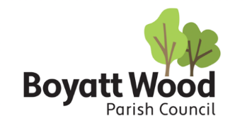
Appendix B

St Catherines Garden Allotments - Application Form

By submitting this application form I consent to my details being retained on a waiting list
and will notify the council of any changes to my details.
Title
Surname
Forename (s)
Address
Postcode:
Contact number | Home: | Mobile:
Email address of applicant
Over 18 | Yes ☐ No ☐
Does your property have a garden/open space | Yes ☐ No ☐
Is this application for an organisation | Yes ☐ No ☐
Name of organisation
Plot size preference | Full (Approx 100m²) ☐ Half (Approx 50m²) ☐ No preference ☐
Additional information
Date
Signature

I confirm that I am the primary contact and aware of the commitment that becoming a garden allotment tenant entail. I have read and understand the Allotment Policy and Rules.
On completion of this form please return to allotments@boyattwood-pc.gov.uk
If you are contacted about an allotment tenancy and do not respond within 14 days, you will be removed from the waiting list.
Note: Boyatt Wood Parish Council reserve the right to refuse any application

